NANOPARTICLE RESEARCH ASSIGNMENT Due: Tues 7th May 2019 (W2)

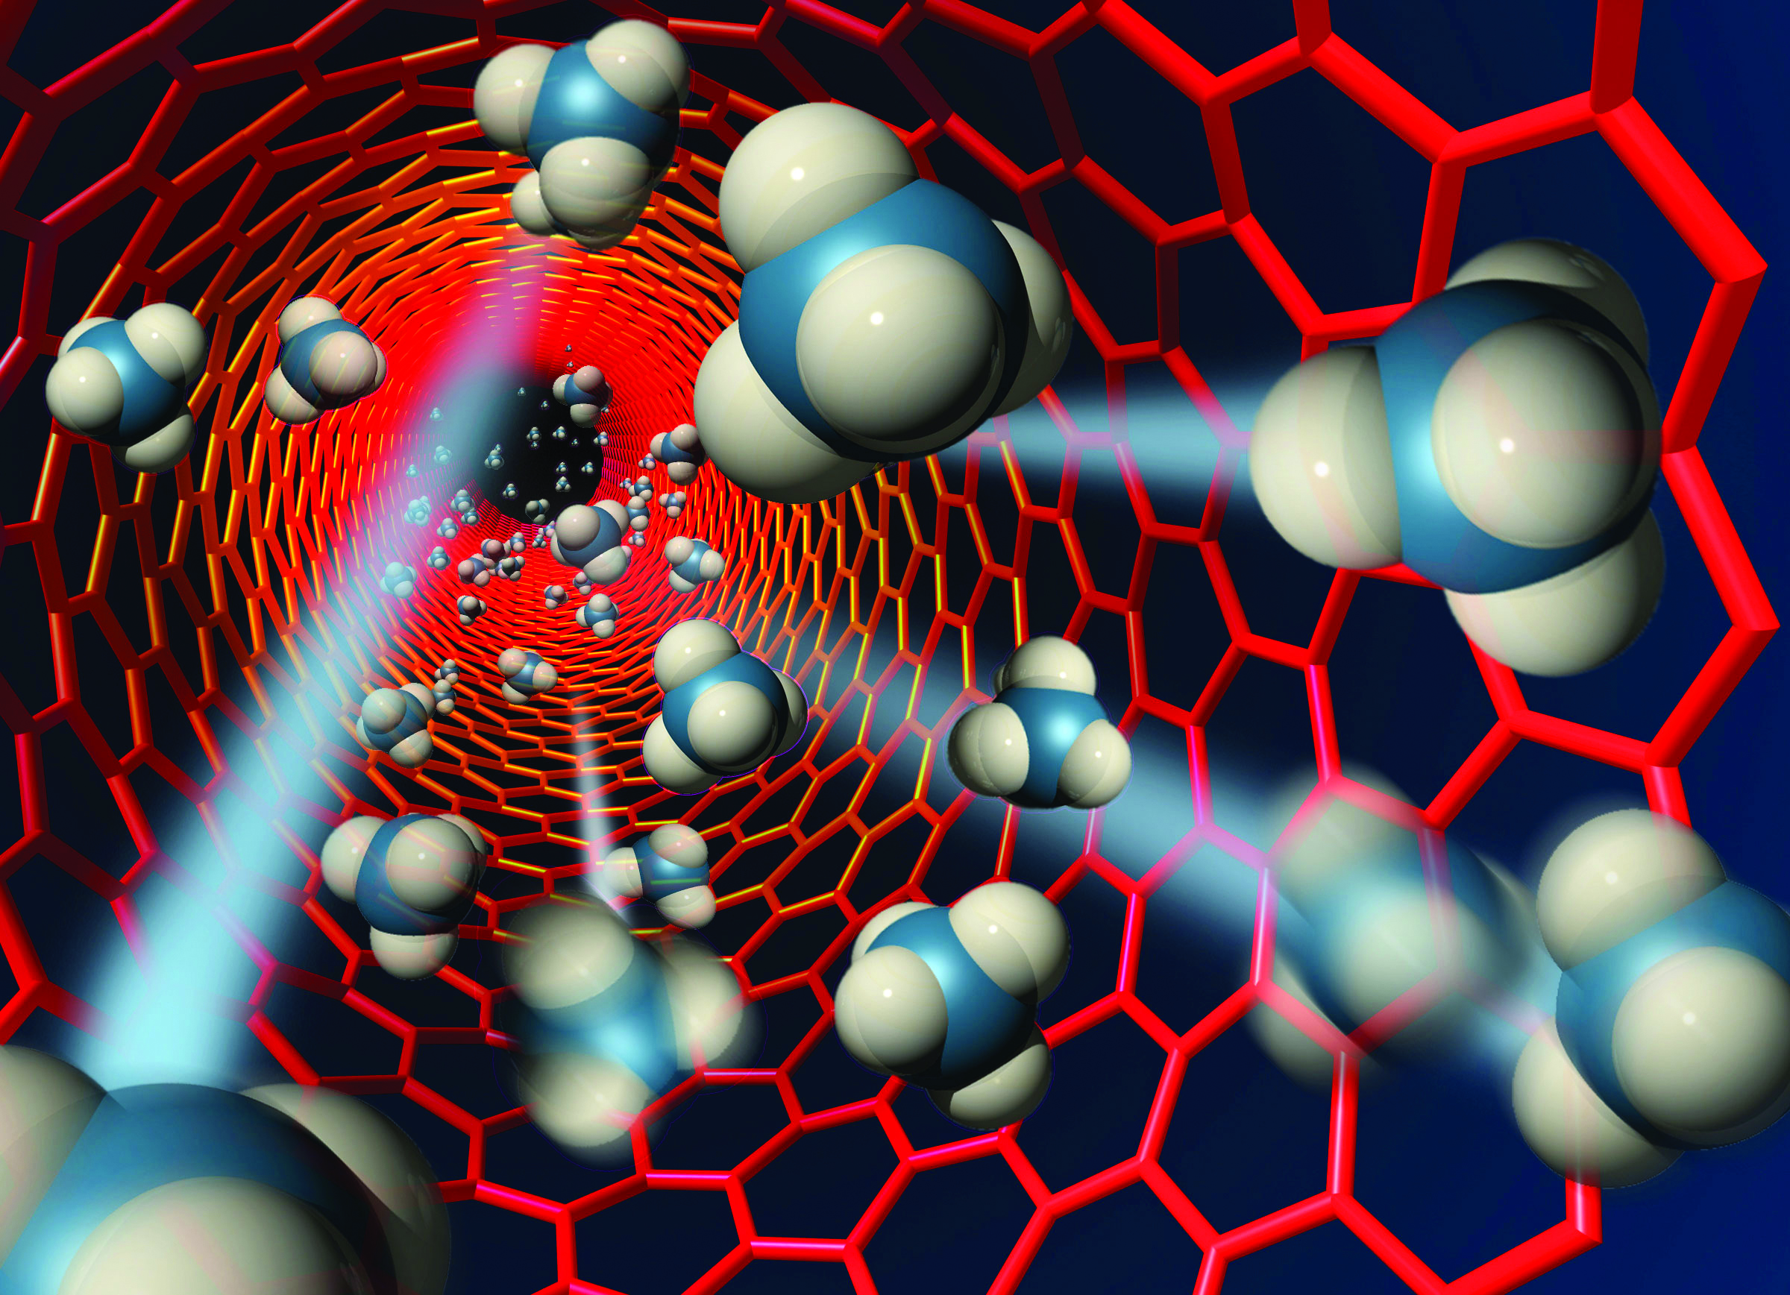 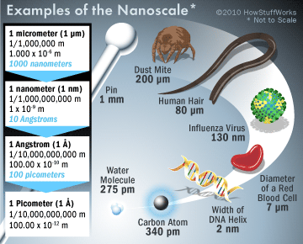

*Matter at the nanoscale can be manipulated to create new materials, composites and devices; the different characteristics of nanomaterials can be used to provide commercially available products. As products are designed on the basis of properties which are different from the bulk material, their use can be associated with potential risks to health, safety and the environment and this has led to regulations being developed to address new and existing nanoform materials.*

**Your task: Conduct research on nanotechnology using the following questions as a guide.**

**Assessment:** Will consist of a **validation test only** + 5 marks allocated for quality of notes

You will be allowed to use your notes to help answer the test questions. Do not copy and paste texts from the internet, you must have a proper set of notes (suggest diagrams, graphic organisers, mindmaps, dot points etc. ) and be able to explain your understanding in your own words.

(Suggested length of notes, about 4 pages, your notes must include at least 4 references))

**Research guidelines:**

**1.** Find out what a nano- metre is , how do you write this in scientific notation? How does a nanometre compare to other units such as kilometres, millimetres, micrometres and Angstroms. Suggest creating a scale. What types of objects are at each of these sizes.

**2.** What is a nanoparticle?

**3.** Give an overview of where nanoparticles are used?

**4.** Find out about one application from each of the following areas (3 altogether)

*What is it, what does it do? How are the nanoparticles for this application made, how do they change the properties of the material, how have they improved the application or is it a brand new application?*

a) Home/ domestic/ everyday use - sunscreen.

b) Medicine –your choice

c) Electronics/technology –your choice

**5**. During your research find out the **advantages** are of using nanotechnology, ie how does it make it better

**6**. What **disadvantages** are there with using nanotechnology, consider effects on health and the environment.

**7**. Be prepared to discuss **5 and 6,** and **evaluate** whether nanotechnology is worthwhile considering the benefits and the risks.